c/- Lady Barron Post Office Flinders Island
TAS 7255
Email: info@vale.org.au

MEDIA RELEASE:
VALE FACT CHECK: Live sheep exports to Morocco unrealistic
Morocco is being touted as an exciting new live export market for Australian sheep, goats and cattle. Australian Livestock Exporters’ Council (ALEC) has claimed that the Moroccan market would benefit WA sheep producers and that it puts paid to the Federal Government’s assertions that livestock exports are a ‘dying trade’.
Vets Against Live Export (VALE) however has fact-checked these assertions.
The tyranny of distance
Morocco is on the north-west corner of Africa. It faces both the Atlantic and Mediterranean Seas and lies directly south of Spain and Portugal, both of which export more live sheep than Australia (Table 1). Morocco is also a relatively short distance by sea from Romania, the largest exporter of European live sheep.
Table 1: Live sheep exports by country
 | Live sheep exported
Romania | 2,331,030
Spain | 1,454,830
Portugal | 501,665
Australia | 418,724
Source: Romania, Spain and Portugal – World Bank: Live sheep exports in 2023.
Australia – DAFF live export statistics, feeder and slaughter sheep exported by sea in 2024.
Australia is not only a fringe player in the global live sheep export trade, it is also a very long way from Morocco (see map).
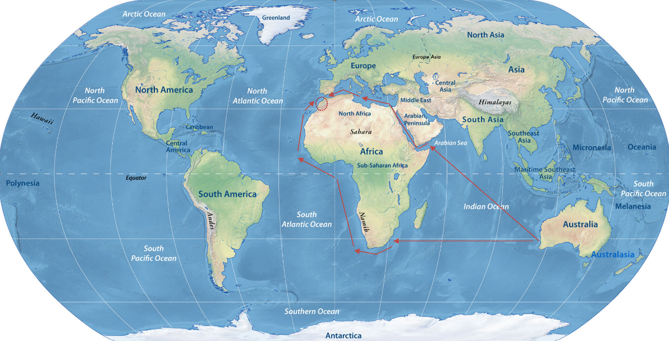
Table 2 shows the distance by sea to Casablanca from Fremantle and from key livestock export ports in Europe assuming the ship travels at 14 knots (https://sea-distances.org/).
Table 2: Sailing distance and times to Casablanca
 | Distance  (nautical miles) | Sailing time
Lisbon, Portugal – Casablanca | 328 nm | 23 hrs
Cartagena, Spain – Casablanca | 424 nm | 1 day, 6 hrs
Costanza, Romania - Casablanca | 2,183 nm | 6 days, 12 hrs
Fremantle – Casablanca (Suez) | 8,401 nm | 25 days, 0 hrs  + Suez delays
Fremantle – Casablanca (Cape of Good Hope) | 9,609 nm | 28 days, 14 hrs

The distance to market with very long sailing times, is a significant commercial obstacle that would be likely to be prohibitive for live sheep exports from Australia to Morocco. Any route through the Suez Canal also has an additional and very expensive transit fee. In addition, regulatory compliance costs are much higher than for Australian sheep than for sheep exported from Europe.
Not enough ships
Australia does not have the ships needed to service existing live sheep customers in the Arabian Gulf States. Now is a period of peak demand, in the lead up to Ramadan starting late February, but since the start of this year there has been only one consignment of sheep exported from Australia to the Arabian Gulf – on a 45 year old ship that was converted to carry livestock thirty years ago, at the end of its life as a car carrier.
Given there are not enough livestock ships meeting Australian maritime standards that are available to service long-standing customers in the Arabian Gulf States, it is difficult to envisage that these ships would be committed to a much longer voyage to Morocco.
By contrast, there are at least 40 livestock ships trading around the Mediterranean Sea and North Atlantic, able to take sheep from Europe to Morocco. Many are very old ships with much lower operating costs than a livestock ship that meets Australian maritime standards.
Cattle: ditto
Any realistic prospect of a live cattle trade from Australia to Morocco would also seem unlikely given that Brazilian cattle are much cheaper than Australian cattle, the sailing time from Brazil to Morocco is less than half that from Australia and, as Beef Central reports, there is an issue with ship availability for Australian cattle also.
Summary
With a very long distance to market and minimum to no shipping available, there appears to be no credible chance of a sustainable live export trade to Morocco. As such, farmers should not be pinning their hope on a new Australian live export trade to Morocco.

ENDS
For information contact VALE at info@vale.org.au

